OSY PTT – 1 Question Bank
2 marks
1) What is System call? State its type?
Ans. A system call is a programmed request where a running user program asks the operating system's kernel to perform a restricted task, such as opening a file, creating a process, or using hardware. It acts as a secure bridge between user applications and system hardware.

Types of system calls :-
1. File System
2. Process Control
3. Memory Management
4. Interprocess Communication (IPC)
5. Device Management

2) Enlist the components of OS?
Ans. 1. Process Management
2. Memory Management
3. File Management
4. Device Management
5. I/O Management
6. Security and Protection
7. Network Management
8. User Interface
9. Secondary Storage Management

3) Compare between command line and Graphical user interface.
Ans. (Use any 4 points)
Parameter | Command Line Interface (CLI) | Graphic User Interface  (GUI)
Definition | Interaction is by typing commands | Interaction with devices is by graphics and visual components and icons
Understanding | Commands need to be memorized | Visual indicators and icons are easy to understand
Memory | Less memory is required for storage | More memory is required as visual components are involved
Working Speed | Use of keyboard for commands makes CLI quicker | Use of mouse for interaction makes it slower
Resources used | Only keyboard | Mouse and keyboard both can be used
Accuracy | High | Comparatively low
Flexibility | Command line interface does not change, remains same over time | Structure and design can change with updates

4) What is real time operating system? State its type with example?
Ans. A real-time operating system (RTOS) is specialized software designed to process data and respond to events within strict, predictable time limits.

The types of RTOS are as follows :-
1. Hard RTOS : These operating systems guarantee that critical tasks are completed within a range of time.
Example : Scientific experiments, medical imaging systems, industrial control systems, weapon systems, robots, air traffic control systems, etc.
2. Soft RTOS : This operating system provides some relaxation in the time limit.
Example : Multimedia systems, digital audio systems, etc.

5) State any four services of Operating System?
Ans. 1. Resource Allocation : Shares the CPU, memory, and devices fairly among tasks.
2. Accounting : Keeps track of how system resources are being used by users and programs.
3. Memory Management : Manages the allocation and deallocation of memory to programs.
4. Security and Protection : Keeps user data safe and blocks unauthorized access.

6) Differentiate between Batch Operating System and Time shared Operating System.
Ans. (Use any 4 points)
Parameter | Batch Operating System | Time shared Operating System
Definition | Jobs are collected and executed in batches without user interaction. | Multiple users/processes can interact with the system simultaneously.
User Interaction | Very little or no direct interaction during execution. | Provides direct interaction with users.
CPU Allocation | A job generally gets CPU according to the batch schedule. | CPU time is divided into small time slices among users/processes.
Response Time | Usually high. | Usually low and fast.
Users | Generally designed for processing large batches of jobs. | Supports multiple users at the same time.
Priority | Jobs are processed according to scheduling policies. | Each user/process gets regular CPU time.
Example | Payroll processing, bank statement generation. | UNIX/Linux multi-user systems.

7) Differentiate between Process and Thread.
Ans. (Use any 4 points)
Parameter | Process | Thread
Definition | A process is a program in execution. | A thread is the smallest unit of execution within a process.
Memory | Process is heavy weight or resource intensive. | Thread is light weight, taking lesser resources than a process
Communication | Less efficient communication | More efficient communication
Creation | Takes more time to create & terminate. | Takes less time to create & terminate.
Context Switching | Context switching is slow | Context switching is fast
Resources | Multiple processes without using threads use more resources. | Multiple threaded processes use fewer resources.
Failure | If one process is blocked, then no other process can execute until the first process is unblocked. | While one thread is blocked and waiting, a second thread in the same task can run.

8) Define CPU and I/O burst cycle?
Ans. 1. CPU Burst :
A CPU burst is the period during which a process executes instructions using the CPU. During this time, the process performs calculations or other CPU-related operations.
2. I/O Burst :
An I/O burst is the period during which a process performs Input/Output operations, such as reading from a disk, keyboard, or network device. During this time, the process usually waits for the I/O operation to complete.

CPU–I/O Burst Cycle :
A process normally alternates between CPU bursts and I/O bursts:
CPU Burst → I/O Burst → CPU Burst → I/O Burst → … → Completion

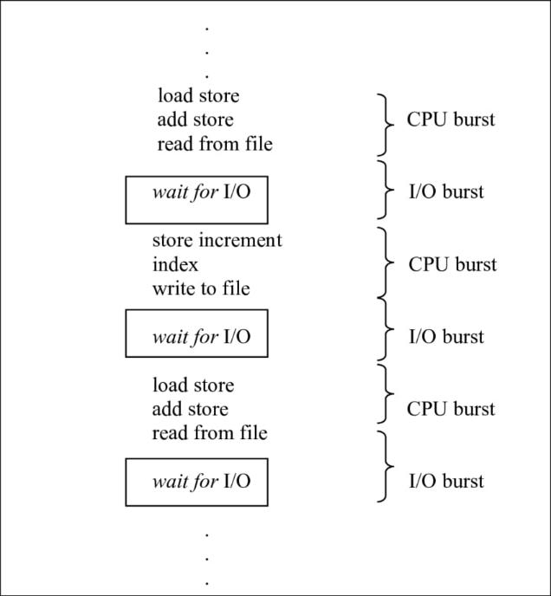
Fig : CPU – I/O Burst Cycle
4 marks
9) Define the term inter process communication. Explain any one technique of IPC.
Ans. 1. Interprocess communication is the mechanism provided by the operating system that allows processes to communicate with each other.
2. Cooperating processes require an Inter-process communication (IPC) mechanism that will allow them to exchange data and information.
3. It helps processes work together efficiently and safely in an operating system.
4. There are two method of IPC : Shared memory and Message passing.
An operating system can implement both methods of communication.
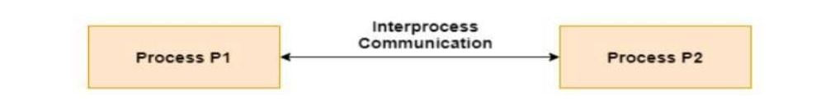
Fig : Interprocess Communication
Shared Memory
1. In this a region of the memory residing in an address space of a process creating a shared memory segment can be accessed by all processes who want to communicate with other processes.
2. All the processes using the shared memory segment should attach to the address space of the shared memory.
3. All the processes can exchange information by reading and/or writing data in shared memory segment.
4. All processes can exchange information by reading and/or writing data to the shared memory segment.
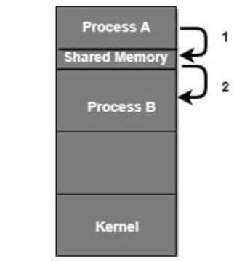
Fig : Shared Memory

10) Write the output of the following commands:
(i) sleep 40 (ii) kill 0 (iii) ps -u user1 (iv) top
Ans. (i) sleep 40
Pauses/suspends the terminal for 40 seconds.
Output: No output is displayed.

(ii) kill 0
Sends a signal to all processes in the current process group. By default, it sends SIGTERM.
Output: Normally, no output if the command succeeds.

(iii) ps -u user1
Displays the processes currently running for the user user1.
Example output:
PID TTY TIME CMD
1234 pts/0 00:00:00 bash
1250 pts/0 00:00:00 ps

(iv) top
Displays a real-time, continuously updated list of running processes, along with CPU usage, memory usage, process IDs, etc.
Example:
PID USER PR NI VIRT RES %CPU %MEM COMMAND
1234 user1 20 0 2500 1200 2.0 0.5 bash

11) With neat labelled diagram, explain process state transition.
Ans. A process in an operating system passes through multiple states as it begins execution, waits for resources, gets scheduled, runs, and eventually finishes. These stages collectively describe the complete lifecycle of a process.

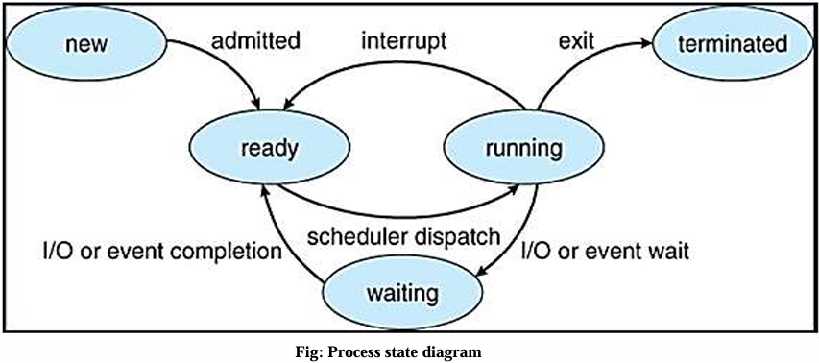
1. New : When a process enters into the system, it is in new state. In this state a process is created.
2. Ready : When the process is loaded into the main memory, it is ready for execution. In this state the process is waiting for processor allocation.
3. Running : When processor is available, system selects one process from main memory and executes all the instructions from that process. So, when a process is in execution, it is in running state. In single user system, only one process can be in the running state. In multiuser system, there can be multiple processes which are in the running state.
4. Waiting State: When a process is in execution, it may request for I/O resources. If the resource is not available, process goes into the waiting state. When the resource is available, the process goes back to ready state.
5. Terminated State: When the process completes its execution, it goes into the terminated state. In this state the memory occupied by the process is released.

12) Describe any four different scheduling criteria.
Ans.
- CPU Utilization
It refers to the percentage of time the CPU is busy executing processes.
Goal: Maximize CPU utilization.
- Throughput
It is the number of processes completed by the CPU in a given period of time.
Goal: Maximize throughput.
- Turnaround Time
It is the total time taken from the submission of a process to its completion.
Goal: Minimize turnaround time.
- Waiting Time
It is the total time a process spends waiting in the ready queue for CPU allocation.
Goal: Minimize waiting time.

13) Explain dual modes of operations of an Operating system.
Ans. To protect the operating system from user programs, the OS works in two modes:
- User Mode
  - In this mode, application programs execute.
  - User programs have limited access to system resources.
  - They cannot directly execute privileged instructions or access hardware.
  - Example: Running a text editor or web browser.
- Kernel Mode (Supervisor Mode)
  - In this mode, the Operating System kernel executes.
  - It has full access to CPU, memory, hardware, and system resources.
  - Privileged operations such as I/O operations and memory management are performed here.
How the modes work
User Program → System Call/Interrupt → Kernel Mode → Operation Performed → User Mode
A mode bit in the hardware indicates the current mode:
- 0 → Kernel Mode
- 1 → User Mode

14) Define PCB. List information contained in PCB and explain.
Ans. Each process is represented as a process control block (PCB) in the operating system. It contains information associated with specific process.
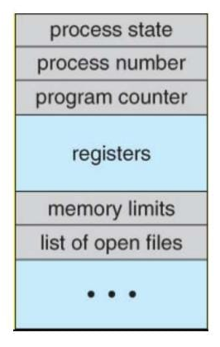
Fig : PCB

1. Process State : It indicates current state of a process. Process state can be new, ready, running, waiting and terminated.
2. Process number : Each process is associated with a unique number which is known process identification number.
3. Program Counter : It indicates the address of the next instruction to be executed for the process.
4. CPU Registers : The registers vary in number and type depending on the computer architecture. Register includes accumulators, index registers and general purpose registers plus any condition code information.
5. Memory Management Information : It includes information such as value of base and limit registers, page tables, segment tables, depending on the memory system used by OS.
6. Accounting Information : This information includes the amount of CPU used, time limits, account holders, job or process number and so on. It also includes information about listed I/O devices allocated to the process. Each PCB gives information about a particular process for which it is designed.

6 marks
15) List the different multi-treading models. Explain multi-threading with advantages and disadvantages.
Ans. 1. Some operating system provide a combined user level thread and Kernel level thread facility.
2. Multithreading improves system performance and responsiveness by allowing multiple threads to share CPU, memory and I/O resources of a single process.
3. Example: In a browser, each tab can be a thread. In MS Word, one thread formats text while another processes inputs.
4. Multithreading models are three types
a) Many to many relationship.
b) Many to one relationship.
c) One to one relationship

Many to one
This model maps many user level threads to one kernel level thread. Thread management is done by thread library in user space.
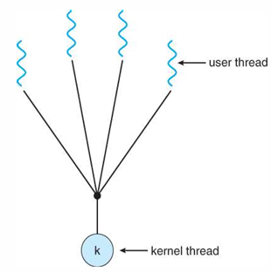
Fig : Many to One
Advantages : It is an efficient model as threads are managed by thread library in user space
Disadvantages : Only one thread can access the kernel at a time, so multiple threads are unable to run in parallel on microprocessor.

One to one
It maps each user thread to a kernel thread. Even a thread makes a blocking call; other thread can run with the kernel thread.
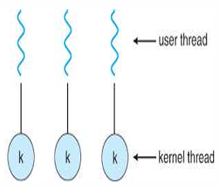
Fig : One to one
Advantages: It allows multiple threads to run in parallel on multiprocessors.
Disadvantages: Creating a user thread requires creating the corresponding kernel thread.

Many to many
This model maps many user level threads to a smaller or equal number of kernel threads. Number of kernel threads may be specific to either a particular application or particular machine.
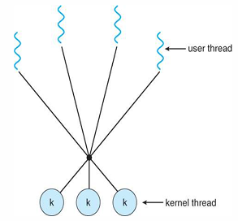
Fig : Many to many
Advantages : Developer can create as many user threads as necessary. Threads can run in parallel on a multiprocessor.

16) List the different types of OS. Explain Multiprocessor OS with advantages and disadvantages.
Ans. The different types of OS are as follows :-
1. Batch OS
2. Multi-programming OS
3. Multitasking OS
4. Multiprocessing OS
5. Realtime OS

Multiprocessor OS
1. Multiprocessor operating systems are used in operating systems to boost the performance of multiple CPUs within a single computer system.
2. Multiple CPUs are linked together so that a job can be divided and executed more quickly. When a job is completed, the results from all CPUs are compiled to provide the final output.
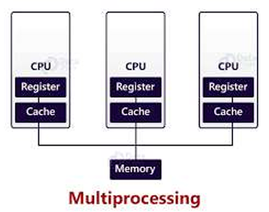
Fig : Multiprocessor OS
There are two types of Multiprocessor OS :-
1. Asymmetric Multiprocessor OS
A processor acts as a master and controls the system. All other processors look for master for instructions or have predefined tasks. It is the responsibility of the master to allocate work to other processors.
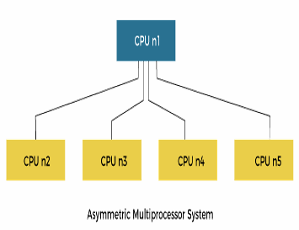
Fig : Asymmetric Multiprocessor OS

2. Symmetric Multiprocessor OS
Multiple identical processors are interconnected to a single shared main memory, with full accessibility to all the I/O devices, unlike asymmetric MP.
In other words, all the processors have common shared(common) memory and same data path or I/O bus as shown in the figure.
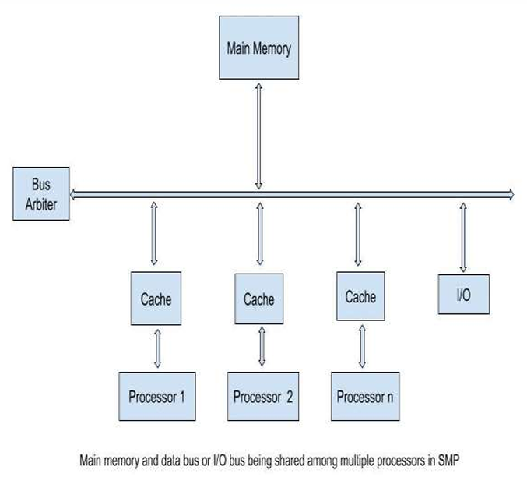
Fig : Symmetric Multiprocessor OS

Advantages of Multiprocessor OS :
- Higher Performance: Multiple processors can execute tasks simultaneously, increasing processing speed.
- Increased Reliability: If one processor fails, other processors may continue working.
- Better Resource Sharing: Processors can share memory, I/O devices, and other system resources.
- Increased Throughput: More processes can be completed in a given amount of time.

Disadvantages of Multiprocessor OS :
- High Cost: Requires multiple processors and additional hardware.
- Complex OS Design: Managing multiple processors and synchronization is complicated.
- Higher Power Consumption: Multiple processors consume more electrical power.
- Maintenance is Difficult: Troubleshooting and maintaining the system can be more difficult.

17) Distinguish between Long term scheduler and Short-term scheduler.
Ans.
Parameter | Long term scheduler | Short term scheduler
Also called | It is job scheduler | It is CPU scheduler
Function | It selects processes from job pool and loads them into memory for execution | It selects processes from ready queue which are ready to execute and allocates CPU to one of them
Access | Access job pool and ready queue | Access ready queue and CPU
Frequency | It executes less frequently. It executes when memory has space to accommodate new process | It executes frequently. It executes when CPU is available for allocation
Speed | Less than short term scheduler | More than Long term scheduler
Controls | It controls the degree of multiprogramming | It provides lesser control over degree of multiprogramming
Main purpose | It chooses a good process that is a mix-up of input/output bound and CPU bound | It chooses a new process for a processor frequently

18) Solve given problem by Using FCFS to calculate average waiting time and turnaround time

Process | Arrival Time | Burst Time
P1 | 0 | 7
P2 | 1 | 4
P3 | 2 | 9
P4 | 3 | 6
P5 | 4 | 8

Ans.
Gantt chart
P1 | P2 | P3 | P4 | P5
0 7 11 20 26 34
Completion Time

Process | Arrival Time | Burst Time | Completion Time
P1 | 0 | 7 | 7
P2 | 1 | 4 | 11
P3 | 2 | 9 | 20
P4 | 3 | 6 | 26
P5 | 4 | 8 | 34

Turn Around Time
TAT = CT – AT
p1 = 7 – 0 = 7
p2 = 11 – 1 = 10
p3 = 20 – 2 = 18
p4 = 26 – 3 = 23
p5 = 34 – 4 = 30

Waiting Time
WT = TAT – BT
p1 = 7 – 7 = 0
p2 = 10 – 4 = 6
p3 = 18 – 9 = 9
p4 = 23 – 6 = 17
p5 = 30 – 8 = 22

Process | Arrival Time | Burst Time | Completion Time | Turnaround Time | Waiting Time
P1 | 0 | 7 | 7 | 7 | 0
P2 | 1 | 4 | 11 | 10 | 6
P3 | 2 | 9 | 20 | 18 | 9
P4 | 3 | 6 | 26 | 23 | 17
P5 | 4 | 8 | 34 | 30 | 22

Average Waiting Time = 0 + 6 + 9 + 17 + 22 = 54 = 10.8 units
5 5

Average Turnaround Time = 7 + 10 + 18 + 23 + 30 = 88 = 17.6 units
5 5
Average Wating Time is 10.8 units & Average Turnaround Time is 17.6 units.

19 ) Solve given problem by Using Round Robin to calculate average waiting time and turnaround time.
Those are the time lines (time slice = 4) :

Process | Arrival Time | Burst Time
P1 | 0 | 12
P2 | 5 | 19
P3 | 8 | 21
P4 | 11 | 13
P5 | 15 | 15

Ans.
Ready Queue
! ! ! ! ! ! ! ! ! ! ! ! ! ! ! ! ! ! ! !
P1 | P2 | P3 | P1 | P4 | P2 | P5 | P3 | P4 | P2 | P5 | P3 | P4 | P2 | P5 | P3 | P4 | P2 | P5 | P3
0

Gantt chart
P1 | P1 | P2 | P3 | P1 | P4 | P2 | P5 | P3 | P4 | P2 | P5
0 4 8 12 16 20 24 28 32 36 40 44 48

P3 | P4 | P2 | P5 | P3 | P4 | P2 | P5 | P3
48 52 56 60 64 68 69 72 75 80
Completion Time

Process | Arrival Time | Burst Time | Completion Time
P1 | 0 | 12 | 20
P2 | 5 | 19 | 72
P3 | 8 | 21 | 80
P4 | 11 | 13 | 69
P5 | 15 | 15 | 75

Turnaround Time
TAT = CT – AT
p1 = 20 – 0 = 20
p2 = 72 – 5 = 67
p3 = 80 – 8 = 72
p4 = 69 – 11 = 58
p5 = 75 – 15 = 60

Waiting Time
WT = TAT – BT
p1 = 20 – 12 = 8
p2 = 67 – 19 = 54
p3 = 72 – 21 = 51
p4 = 58 – 13 = 45
p5 = 60 – 15 = 45

Process | Arrival Time | Burst Time | Completion Time | Turnaround Time | Waiting Time
P1 | 0 | 12 | 20 | 20 | 8
P2 | 5 | 19 | 72 | 67 | 48
P3 | 8 | 21 | 80 | 72 | 51
P4 | 11 | 13 | 69 | 58 | 45
P5 | 15 | 15 | 75 | 60 | 45

Average Waiting Time = 8 + 48 + 51 + 45 + 45 = 197 = 39.4 units
5 5

Average Turnaround Time = 20 + 67 + 72 + 58 + 60 = 277 = 55.4 units
5 5

Average Waiting Time is 39.4 units & Average Turnaround Time is 55.4 units.

